## **Hardware Essentials Overview**

This guide provides detailed tutorials on various hardware essentials, including BIOS/UEFI configurations, storage devices, operating systems, virtualization, and printer configurations.

## **BIOS and UEFI**

## **Introduction to BIOS and UEFI**

* **BIOS (Basic Input/Output System)**: The firmware that initializes hardware during the booting process. It performs a Power-On Self-Test (POST) to check hardware functionality before loading the operating system.
* **UEFI (Unified Extensible Firmware Interface)**: A modern replacement for BIOS that provides faster boot times, support for larger hard drives, and enhanced security features like Secure Boot. UEFI can directly boot from a partition without needing a bootloader in the traditional sense.

## **System Boot Process**

**Power On**: The computer powers up, initializing the CPU and other components.

**POST**: The firmware checks hardware components for errors.

**Boot Device Selection**: BIOS/UEFI searches for bootable devices based on configured settings.

**Loading the Bootloader**: For BIOS, it reads the Master Boot Record (MBR); for UEFI, it scans the GUID Partition Table (GPT) for valid EFI System Partitions.

**Operating System Initialization**: The bootloader loads the OS kernel into memory.

## **Configuring BIOS/UEFI Security Settings**

To configure security settings in BIOS/UEFI:

Access the firmware settings during boot (commonly by pressing Esc, Delete, F1, or F2).

Navigate to the **Security** section.

Enable features like **Secure Boot** to prevent unauthorized software from loading during startup.

Set a supervisor password to restrict access to firmware settings.

## **Storage Devices Overview**

## **Types of Storage Devices**

**SATA (Serial ATA)**: A widely used interface for connecting hard drives and SSDs. It supports both HDDs and SSDs.

**SSD (Solid State Drive)**: Uses flash memory for faster data access compared to traditional HDDs.

**M.2 SSD**: A compact form factor that connects directly to the motherboard via PCIe or SATA interfaces, offering high-speed data transfer rates.

## **Windows OS Desktop Application Support**

Windows OS supports a wide range of desktop applications, including productivity software, development tools, and games. Applications can be installed from various sources such as Microsoft Store or direct downloads from developers.

## **Remote Desktop and Remote Assistance**

**Remote Desktop**: Allows users to connect to another computer over a network and interact with its desktop as if they were physically present.

**Remote Assistance**: Enables one user to invite another user to help troubleshoot issues on their computer remotely.

## **Partitions, Volumes, and File Systems**

**Partitions**: Sections of a hard drive that are treated as separate disks by the operating system.

**Volumes**: Logical storage units created from one or more partitions.

**File Systems**: Methods of organizing data on storage devices (e.g., NTFS for Windows).

## **Virtual Memory Basics**

Virtual memory extends physical memory by using disk space to simulate additional RAM. This allows systems to run larger applications than would fit in physical memory alone.

## **Driver Installation and Rollback**

Install drivers through Device Manager or manufacturer websites.

Rollback drivers if issues arise by selecting the previous version in Device Manager.

## **Operating System Maintenance & Troubleshooting**

Regular maintenance includes:

Updating software and drivers.

Running disk cleanup utilities.

Monitoring system performance and resolving conflicts.

## **Printing Configuration**

## **Sharing Printers**

* Connect the printer to a network or directly to a computer.
* Enable printer sharing in the operating system settings.
* Configure network settings if necessary.

## **Troubleshooting Printers**

Common troubleshooting steps include:

* Checking connections and power status.
* Updating printer drivers.
* Running built-in diagnostics tools available in Windows.

## **Virtualization Overview**

Virtualization allows multiple operating systems to run on a single physical machine using hypervisors like VMware or Hyper-V. This technology enhances resource utilization and isolation between different environments.

## **Implementation Facts**

* Ensure hardware supports virtualization (e.g., Intel VT-x or AMD-V).
* Use compatible hypervisor software for managing virtual machines.

## **Virtual Networking Implementations**

Virtual networking involves creating virtual networks within physical networks using software-defined networking techniques. This allows for efficient resource allocation and management of network traffic. By following these guidelines and tutorials, users can effectively manage their hardware essentials and optimize their computing environments across various applications and technologies.

**Scenario 1: BIOS, UEFI, System Boot Process**

**Scenario:** A user's computer is not booting up correctly. It's stuck on a black screen with a blinking cursor.

**Responses:**

1. **Ask the user to:**
   * Check if all cables are properly connected (power, monitor, keyboard, mouse).
   * Try restarting the computer a few times.
2. **If the issue persists, suggest:**
   * Entering the BIOS/UEFI setup to check boot order and other settings.
   * Resetting the CMOS battery to clear BIOS settings.
   * Using a bootable USB drive to boot into a diagnostic tool or operating system.

**Output:**

* Computer boots up successfully.
* User can access the BIOS/UEFI setup.
* User can boot into a diagnostic tool or operating system.

**Scenario 2: Configure BIOS/UEFI Security Settings**

**Scenario:** A company wants to enhance the security of its workstations.

**Responses:**

1. **Recommend the following BIOS/UEFI security settings:**
   * **Secure Boot:** Enable to prevent unauthorized boot loaders.
   * **Password Protection:** Set a strong password to access the BIOS/UEFI setup.
   * **TPM (Trusted Platform Module):** Enable to provide hardware-based security features.
   * **UEFI Network Stack:** Disable unnecessary network boot options.

**Output:**

* Increased security of company workstations.
* Reduced risk of unauthorized access and malware infection.

**Scenario 3: Storage Devices, SATA, SSD & M.2 SSD Overview**

**Scenario:** A user wants to upgrade their laptop's storage.

**Responses:**

1. **Explain the differences between SATA, SSD, and M.2 SSD:**
   * **SATA SSD:** Slower but more affordable.
   * **M.2 SSD:** Faster and more efficient, often used in laptops.
2. **Guide the user on:**
   * Identifying the available storage slot (SATA or M.2).
   * Choosing a compatible SSD.
   * Installing the new SSD.

**Output:**

* User's laptop has faster storage and improved performance.

**Scenario 4: Windows OS desktop application support**

**Scenario:** A user is having trouble installing a software application.

**Responses:**

1. **Check for compatibility:**
   * Ensure the application is compatible with the user's Windows version and system requirements.
2. **Try different installation methods:**
   * Use the application's installer or the Microsoft Store.
3. **Troubleshoot installation errors:**
   * Check for antivirus interference, administrator privileges, or missing dependencies.

**Output:**

* Application is successfully installed and working.

**Scenario 5: Remote Desktop, Remote Assistance**

**Scenario:** A technician needs to remotely troubleshoot a user's computer.

**Responses:**

1. **Use Remote Desktop or Remote Assistance:**
   * Establish a remote connection to the user's computer.
   * Diagnose and fix the issue remotely.
2. **Provide clear instructions to the user:**
   * Guide the user through the process of setting up remote access.
   * Ensure a stable internet connection.

**Output:**

* Issue is resolved remotely.
* User's computer is working correctly.

# UEFI vs BIOS: What's the Difference?

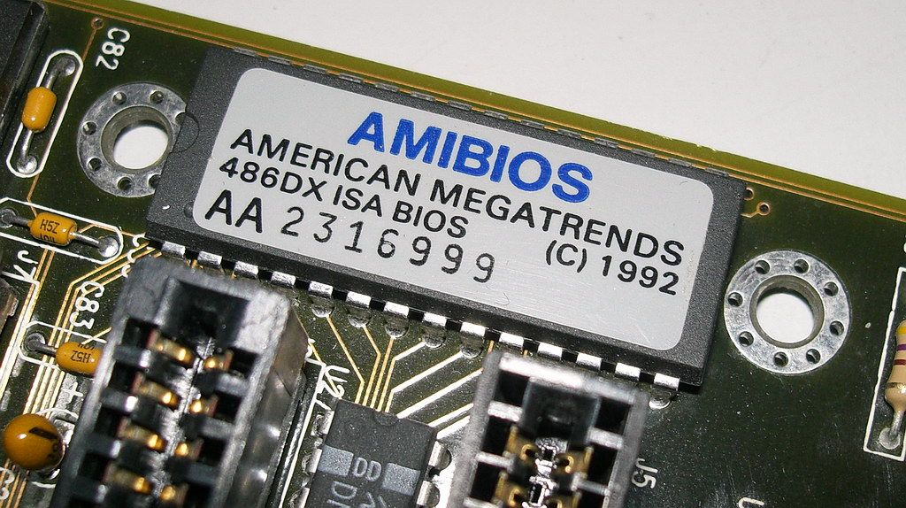

So you might have heard the acronyms BIOS and UEFI thrown around, especially when trying to switch Operating Systems or messing around with overclocking.

And you might know what these acronyms stand for (Unified Extensible Firmware Interface and Basic Input/output System, respectively). But have you ever wondered how they're used in a computer system?

Let's demystify these terms and their meanings now.

## Boot Procedure

First things first – I know we're deviating from the topic, but I promise this will help you with some concepts later on.

So, how does a computer boot? Let's go step by step:

* You press the power button on your laptop/desktop.
* The CPU starts up, but needs some instructions to work on (remember, the CPU always needs to do something). Since the main memory is empty at this stage, CPU defers to load instructions from the firmware chip on the motherboard and begins executing instructions.
* The firmware code does a Power On Self Test (POST), initializes the remaining hardware, detects the connected peripherals (mouse, keyboard, pend rive etc.) and checks if all connected devices are healthy. You might remember it as a 'beep' that desktops used to make after POST is successful.
* Finally, the firmware code cycles through all storage devices and looks for a boot-loader (usually located in first sector of a disk). If the boot-loader is found, then the firmware hands over control of the computer to it.
* We don't need to know more about this topic for the purposes of this article. But if you're interested, then read on (otherwise, you can skip to next section).
* So now that the boot-loader is loaded, its job is to load the rest of the operating system. GRUB is one such boot-loader that is capable of loading unix-like operating systems and is also able to chain-load Windows OS. Boot-loader is only available in the first sector of a disk, which is 512 bytes. Given the complexity of modern operating systems, some of these boot-loaders tend to do multi-stage loading, where the main boot-loader loads the second-stage-boot-loader in an environment which is not restricted to 512 bytes.
* The boot-loader then loads the [kernel](https://en.wikipedia.org/wiki/Kernel_(operating_system)) into memory. Unix-like operating systems then run the init process (the master process, from which other processes are forked/executed) and finally initialize the [run-levels](https://en.wikipedia.org/wiki/Runlevel).
* In Windows, wininit.exe is loaded along with some other processes like services.exe for service control, lsass.exe for local security and authority (similar to run-levels) and lsm.exe for local session management.
* After all this, and after some other drivers are initialized, the Graphical User Inferface (GUI) is loaded and you are presented with the login screen.

## BIOS:

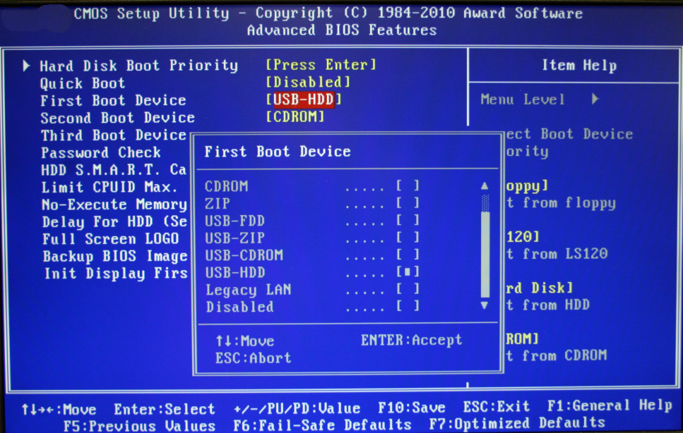

BIOS stands for Basic Input/Output System, the firmware we talked about in the above boot procedure.

It is stored on an EPROM (Erasable Programmable Read-Only Memory), allowing the manufacturer to push out updates easily.

It provides many helper functions that allow reading boot sectors of attached storage and printing things on screen. You can access BIOS during the initial phases of the boot procedure by pressing del, F2 or F10.

## UEFI:

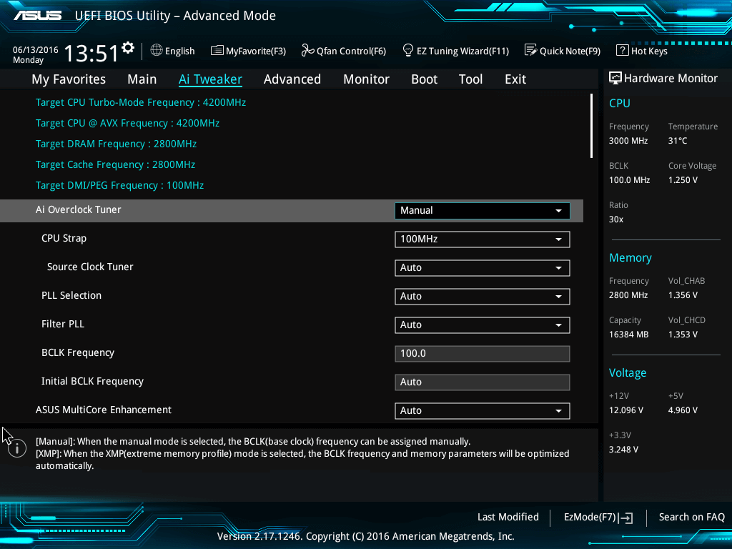

ASUS UEFI

UEFI stands for Unified Extensible Firmware Interface. It does the same job as a BIOS, but with one basic difference: it stores all data about initialization and startup in an .efi file, instead of storing it on the firmware.

This .efi file is stored on a special partition called EFI System Partition (ESP) on the hard disk. This ESP partition also contains the bootloader.

UEFI was designed to overcome many limitations of the old BIOS, including:

* UEFI supports drive sizes up to 9 zettabytes, whereas BIOS only supports 2.2 terabytes.
* UEFI provides faster boot time.
* UEFI has discrete driver support, while BIOS has drive support stored in its ROM, so updating BIOS firmware is a bit difficult.
* UEFI offers security like "Secure Boot", which prevents the computer from booting from unauthorized/unsigned applications. This helps in preventing rootkits, but also hampers dual-booting, as it treats other OS as unsigned applications. Currently, only Windows and Ubuntu are signed OS (let me know if I am wrong).
* UEFI runs in 32bit or 64bit mode, whereas BIOS runs in 16bit mode. So UEFI is able to provide a GUI (navigation with mouse) as opposed to BIOS which allows navigation only using the keyboard.

## You might not need UEFI

Though all modern computers come equipped with UEFI by default, some reasons why you might choose BIOS over UEFI are:

* If you're beginner and don't care about messing with any type of firmware, BIOS is for you.
* If you have < 2 TB per hard disk or partition, you can go with BIOS.
* BIOS allows running multiple operating systems without changing any settings This can be a security issue from a modern standpoint, but hey, no hassles for the user.
* BIOS provides system information to the operating system. So if your OS runs in 16 bit mode, it does not require writing code for interacting with hardware. It can directly use methods provided by BIOS. Else if the OS switches over to 32bit or 64bit mode, then it needs to provide its own subroutines for interacting with hardware.
* If you are someone who prefers a keyboard and text based UI over navigation with a mouse and GUI, then BIOS is for you.
* UEFI takes these limitations into account and provides a Legacy mode. In it you can run everything as if you had a BIOS firmware. But keep in mind that Intel has announced that it won't support traditional BIOS from 2020.

Here are examples for each aspect of the BIOS vs. UEFI discussion based on the provided details:

### ****Boot Procedure****

#### Example:

* **Scenario:** You press the power button on a desktop computer.
  + The CPU begins execution by accessing the firmware (BIOS or UEFI) stored on the motherboard's chip.
  + The firmware performs a POST, checks connected devices, and locates the bootloader on the storage device's first sector (e.g., GRUB bootloader on an SSD).
  + GRUB loads the operating system (e.g., Ubuntu) kernel into memory, initializes drivers, and displays the login screen.

### ****BIOS****

* **Scenario 1: Legacy System Compatibility**
  + A user has a computer with an older BIOS firmware running in 16-bit mode. They navigate the BIOS interface using keyboard shortcuts (e.g., ↑, ↓, Enter) to change the boot order and boot into a Windows XP installation from a USB.
* **Scenario 2: Drive Size Limitation**
  + A user tries to connect a 3 TB hard drive to a legacy BIOS system. The BIOS only detects 2.2 TB of the drive because of its addressing limitations.

### ****UEFI****

#### Example 1: Faster Boot Times

* **Scenario:**
  + A modern laptop with UEFI firmware boots into Windows 11 in less than 10 seconds, thanks to its optimized initialization processes and faster hardware detection.

#### Example 2: Secure Boot

* **Scenario:**
  + A user attempts to boot an unsigned Linux distribution on a UEFI-enabled system with Secure Boot. The system refuses to load the OS, requiring the user to disable Secure Boot in the UEFI settings to proceed.

#### Example 3: GUI Navigation

* **Scenario:**
  + On an ASUS motherboard, a user enters UEFI settings. Using a mouse, they adjust CPU overclocking and enable XMP profiles for faster RAM speeds through an intuitive graphical interface.

### ****UEFI vs. BIOS: Drive Support****

#### Example:

* **Scenario:**
  + A user has a 4 TB external hard drive formatted as GPT (GUID Partition Table).
  + On a UEFI-enabled laptop, the drive is fully accessible.
  + On an older BIOS-only desktop, only the first 2.2 TB of the drive is recognized.

### ****Security: Secure Boot****

#### Example:

* **Scenario:**
  + A corporate laptop with UEFI and Secure Boot enabled prevents a rootkit-infected USB drive from booting. This safeguards the system from malware at the firmware level.

### ****Backward Compatibility: Legacy Mode****

#### Example:

* **Scenario:**
  + A user with a dual-boot system (Windows 7 and Ubuntu) uses UEFI's Legacy mode to avoid issues with Secure Boot, enabling both operating systems to coexist seamlessly.

### ****User Preferences****

#### Example 1: Simplicity

* **Scenario:**
  + A user unfamiliar with firmware settings prefers a legacy BIOS system with a simple text-based interface over UEFI's GUI.

#### Example 2: OS Compatibility

* **Scenario:**
  + A developer working with 16-bit embedded software on older hardware prefers BIOS for direct interaction with hardware subroutines.

### ****Conclusion****

#### Example:

* **Scenario:**
  + A tech enthusiast uses UEFI for its modern features, such as Secure Boot and support for larger drives, on a gaming PC. However, for experimenting with older operating systems on a retro machine, they switch to BIOS on a secondary system for compatibility.

These examples help illustrate practical applications of both BIOS and UEFI in real-world scenarios. Let me know if you'd like more in-depth details or additional examples!

### ****Boot Procedure****

#### Example 1: Multi-Stage Boot Process

* **Scenario:**  
  A user wants to dual-boot Ubuntu and Windows on a UEFI system.
  + The UEFI firmware loads the GRUB bootloader from the EFI partition.
  + GRUB presents a menu for selecting Ubuntu or Windows.
  + Selecting Ubuntu loads its kernel into memory and initializes the operating system.
  + If Windows is selected, GRUB chain-loads the Windows Boot Manager.

#### Example 2: POST Failure in BIOS

* **Scenario:**  
  A desktop emits continuous beeps during the boot process.
  + The user refers to the motherboard manual and learns the beeps indicate faulty RAM.
  + Replacing the RAM module allows the system to pass POST and proceed with booting.

### ****BIOS****

#### Example 1: Overclocking on Legacy Hardware

* **Scenario:**  
  A gamer uses the BIOS to increase their CPU clock speed on an older system.
  + They adjust the "CPU Multiplier" using keyboard navigation.
  + Save changes and reboot the system to test stability under a gaming workload.

#### Example 2: Installing DOS

* **Scenario:**  
  A developer installs MS-DOS on a legacy system for testing purposes.
  + The BIOS detects the bootable floppy disk, allowing the installation process to begin.
  + DOS operates seamlessly with BIOS subroutines for disk and peripheral access.

### ****UEFI****

#### Example 1: UEFI Secure Boot with Linux

* **Scenario:**  
  A user wants to install Fedora on a UEFI system with Secure Boot.
  + Fedora, being a signed OS, installs without any issues.
  + The system boots Fedora securely, preventing unsigned bootloaders from compromising the setup.

#### Example 2: UEFI Fast Boot for Quick Startups

* **Scenario:**  
  On a modern laptop, the user enables "Fast Boot" in UEFI settings.
  + Peripheral initialization is skipped or deferred, and the system boots into Windows 11 within 5 seconds.

#### Example 3: Recovering from a Corrupted Bootloader

* **Scenario:**  
  A user accidentally deletes the EFI partition on their system.
  + Using a UEFI firmware boot menu, they boot a recovery USB.
  + The recovery tool recreates the EFI partition and reinstalls the bootloader, restoring system functionality.

### ****Drive Support****

#### Example 1: Large Drive Compatibility

* **Scenario:**  
  A video editor installs an 8 TB hard drive on their system.
  + On UEFI, the drive is fully usable when formatted with GPT.
  + On BIOS, only 2.2 TB of the drive is accessible due to its addressing limitations.

#### Example 2: Migrating OS from MBR to GPT

* **Scenario:**  
  A user upgrades to a UEFI motherboard and wants to use GPT for their storage drives.
  + They convert their system drive from MBR to GPT using a disk management tool.
  + The system boots seamlessly in UEFI mode after the conversion.

### ****Security: Secure Boot****

#### Example 1: Preventing Malware

* **Scenario:**  
  A business laptop with UEFI Secure Boot enabled blocks a ransomware-infected USB drive from booting.
  + The user receives a warning, prompting them to disconnect the malicious drive.

#### Example 2: Adding Custom Secure Boot Keys

* **Scenario:**  
  A developer creates their own operating system and wants to run it on a UEFI-enabled machine with Secure Boot.
  + They sign the OS bootloader with their custom key and add it to the UEFI firmware.
  + Secure Boot verifies the custom key and allows the OS to boot securely.

### ****Legacy Mode in UEFI****

#### Example 1: Running Older Operating Systems

* **Scenario:**  
  A user needs to install Windows XP on a modern UEFI-enabled system.
  + They enable Legacy Mode in the UEFI settings.
  + The system mimics traditional BIOS behavior, allowing the installation of Windows XP.

#### Example 2: Dual-Booting Without Secure Boot Issues

* **Scenario:**  
  A user dual-boots an older version of Linux with Windows 10.
  + They disable Secure Boot in UEFI and enable Legacy Mode to avoid signature verification errors.

### ****Graphical Interface in UEFI****

#### Example 1: Configuring RAID

* **Scenario:**  
  A user sets up a RAID 1 array using UEFI’s graphical interface.
  + They use the mouse to select two drives and enable RAID mirroring.
  + The UEFI saves the configuration and initializes the RAID setup before booting the OS.

#### Example 2: User-Friendly Overclocking

* **Scenario:**  
  On a gaming motherboard, the user enters the UEFI setup and adjusts CPU voltage and frequency using drag-and-drop sliders.

### ****When to Choose BIOS or UEFI****

#### Example 1: BIOS for Compatibility

* **Scenario:**  
  A user refurbishes a PC with legacy hardware and chooses BIOS for compatibility with older peripherals like parallel printers and IDE drives.

#### Example 2: UEFI for Advanced Features

* **Scenario:**  
  A developer working on a large dataset selects UEFI because of its GPT support for drives larger than 2 TB.

These **additional examples** provide diverse scenarios where BIOS and UEFI are applied, catering to various user needs and technical challenges. Let me know if you'd like more details on specific features!

**Slide 1: Hardware Essentials Overview**

**Content:**

* Introduction to the training: Purpose and objectives.
* Key topics: BIOS, UEFI, Boot Process, Storage, Virtualization, and Troubleshooting.
* Learning goals: Understand hardware concepts and perform basic configurations.

**Engagement:**

* Ask participants about their prior experience with hardware configuration.

**Slide 2: Overview of BIOS and UEFI**

**Content:**

* **BIOS (Basic Input/Output System):** Legacy firmware that initializes hardware and loads the OS.
* **UEFI (Unified Extensible Firmware Interface):** Modern alternative with faster boot times, better security, and graphical interface.
* **Differences:** Support for larger storage drives, secure boot functionality in UEFI.

**Example:**

* Show images of BIOS and UEFI interfaces.

**Activity:**

* Discuss how BIOS/UEFI impacts system performance.

**Slide 3: System Boot Process**

**Content:**

1. **Power-On Self-Test (POST):** Hardware check for essential components.
2. **Bootloader Execution:** Loading OS kernel into memory.
3. **OS Initialization:** Starting system services and loading user interface.

**Diagram:**

* Add a flowchart of the boot process.

**Example:**

* Compare boot times between an HDD and SSD-based system.

**Slide 4: Hands-On: Accessing BIOS/UEFI**

**Content:**

* Keys to access BIOS/UEFI (e.g., F2, DEL, ESC).
* Navigation tips for common settings.

**Activity:**

* Demonstrate accessing BIOS settings on a test machine.

**Slide 5: Importance of BIOS/UEFI Security**

**Content:**

* **Risks:** Unauthorized changes to boot configurations, exposure to malware.
* **Secure Boot:** Ensures only signed software can load during startup.

**Example:**

* Explain how Secure Boot prevents bootkits.

**Slide 6: Key Security Settings in BIOS/UEFI**

**Content:**

* Password protection for BIOS settings.
* Enabling TPM (Trusted Platform Module) for encryption.

**Activity:**

* Discuss real-world scenarios where BIOS/UEFI security failed.

**Slide 7: Hands-On: Configuring BIOS Security**

**Content:**

* Step-by-step guide for setting up:
  + BIOS password.
  + Enabling Secure Boot.

**Activity:**

* Live demonstration or guided walkthrough.

**Slide 8: Storage Devices Overview**

**Content:**

* **HDD:** Slower, affordable storage for large data.
* **SSD:** Faster, lightweight, and durable.
* **M.2 SSD and NVMe:** High-speed storage for modern systems.

**Example:**

* Compare read/write speeds of HDD vs SSD.

**Slide 9: SATA vs SSD vs M.2 SSD**

**Content:**

* Speed differences and compatibility.
* Practical applications (e.g., gaming vs enterprise storage).

**Example:**

* Show a side-by-side performance comparison using real metrics.

**Slide 10: Live Example: Installing M.2 SSD**

**Content:**

* Tools required for installation.
* Step-by-step guide with images.

**Activity:**

* Encourage participants to simulate installation on a test machine.

**Slide 11: Introduction to OS Support**

**Content:**

* Overview of desktop application support.
* Role of IT in ensuring smooth operations.

**Activity:**

* Discuss participants’ challenges in supporting OS issues.

**Slide 12: Common Troubleshooting Scenarios**

**Content:**

* Application crashes.
* Unresponsive systems.

**Example:**

* Troubleshooting a failed OS update.

**Slide 13: Case Study: Resolving Application Errors**

**Content:**

* Scenario: Troubleshooting a driver incompatibility issue.
* Resolution steps.

**Slide 14: Introduction to Remote Access**

**Content:**

* Definition and purpose.
* Types: RDP, TeamViewer, VNC.

**Activity:**

* Discuss the pros and cons of remote access tools.

**Slide 15: Remote Desktop Setup**

**Content:**

* Requirements for setting up RDP.
* Steps to enable RDP in Windows.

**Activity:**

* Demonstrate establishing a remote desktop connection.

**Slide 16: Troubleshooting Remote Access Issues**

**Content:**

* Common issues: Firewall blocks, incorrect IPs.
* Solutions and best practices.

**Slide 17: Introduction to Disk Management**

**Content:**

* Overview of partitions, volumes, and file systems.
* Benefits of logical storage organization.

**Slide 18: File Systems Comparison**

**Content:**

* NTFS: Advanced file permissions, journaling.
* FAT32: Compatibility with older systems.

**Activity:**

* Discuss scenarios where exFAT is better than NTFS.

**Slide 19: Hands-On: Partitioning a Drive**

**Content:**

* Using Disk Management in Windows.

**Activity:**

* Create and format partitions on a test system.

**Slide 20: Understanding Virtual Memory**

**Content:**

* Purpose: Expands RAM using disk space.
* Concepts: Paging, swap files.

**Example:**

* Monitor virtual memory usage using Task Manager.

**Slide 21: Driver Installation Basics**

**Content:**

* Overview of hardware drivers.
* Types: Generic vs manufacturer-specific.

**Slide 22: Driver Rollback Process**

**Content:**

* Why rollback is necessary.
* Step-by-step guide.

**Slide 23: OS Maintenance Best Practices**

**Content:**

* Update schedules.
* Disk cleanup utilities.

**Slide 24: Troubleshooting Framework**

**Content:**

* Step 1: Identify the issue.
* Step 2: Test possible solutions.

**Slide 25: Case Study: Resolving OS Slowdowns**

**Content:**

* Identify performance bottlenecks.
* Apply fixes (e.g., disabling startup apps).

**Slide 26: Setting Up a Printer**

**Content:**

* Differences between local and network printers.

**Activity:**

* Walk through printer installation steps.

**Slide 27: Sharing a Printer**

**Content:**

* Enable printer sharing in Windows.

**Activity:**

* Test sharing within the group.

**Slide 28: Troubleshooting Printing Issues**

**Content:**

* Paper jams, driver conflicts.

**Slide 29: What is Virtualization?**

**Content:**

* Definition and types.
* Benefits: Cost savings, scalability.

**Slide 30: Virtualization Use Cases**

**Content:**

* Examples in businesses: Testing, disaster recovery.

**Slide 31: Setting Up Virtualization**

**Content:**

* Hardware and software requirements.

**Slide 32: Examples of Virtualization Tools**

**Content:**

* Hyper-V, VMware, VirtualBox.

**Slide 33: Hands-On: Creating a Virtual Machine**

**Content:**

* Configure a VM step-by-step.

**Slide 34: Virtual Networking Basics**

**Content:**

* Definitions: Bridged, NAT, Host-only networking.

**Slide 35: Configuring Virtual Networks**

**Content:**

* Network settings in a VM environment.

**Slide 36: Troubleshooting Virtual Network Issues**

**Content:**

* Identify and resolve connectivity issues.

**Slide 37: Knowledge Check**

**Content:**

* 5-10 MCQs based on session content.

**Slide 38: Hands-On Exercises**

**Content:**

* Tasks for BIOS, Storage, and Virtualization.